TALK TO THE PAW – IMPROVING COMMUNICATION WITH OUR DOGS
Duration Marker
A duration marker, or a continuation marker is a word that tells our dog he/she is doing well and to keep doing what they are doing. We many times will use this when we are ready to add in duration or time that our dog is in a sit, down, stand or Place
We can also use it when we are working on heeling. When our dog is doing well with their heeling position, we can give our duration or continuation marker word.
The word “good” is the most common duration / continuation maker word but you can use whatever you want as long as you are consistent
When first introducing it, say “good” only once before giving your release marker. Dogs need to learn that this word means to keep doing whatever behavior we have asked them to do. If we ask the dog to stay in the position too long early in the training, they will be more likely to get up out of the position.
Things to consider:
Environment: are you in a familiar place or an environment that is new to our dog?
Distractions: what is going on within the environment you are training in? Are there other dogs, toys, food, people, noises, etc that are normally not part of the training environment?
Whoa! Slow Down: did you skip steps that your dog needs to understand what you are teaching? Some dogs can learn in 10 puzzle pieces and some need 100.
Training Time: how long have you been training? Have you gone too long to early in the training?
Length of Exercise: have you built enough chops for your dog to hold the position, or perform multiple positions?
Motivation: have you built enough motivation and engagement between you and your dog?
Are you fun: are you creating a fun training environment for your dog or are you more boring than dirt? Are you more rewarding than the environment?

End of Exercise Marker
Having a word or 2 word phrase that tells the dog training is done will be important. The dog needs to know when the session is over and that the option for reward has closed. Words/phrases like: done, all done, enough & finished are the most common, but again, you can choose what word/phrase you use – just be consistent.

Putting in Into Action
Engage, sit, down, come, spin, twist, heel.

Additional Option
Many dog owners like to add in a “ready” cue. They will have a word that tells the dog we are starting training. This is primarily used in the sport dog world but pet / companion dog owners can find it very helpful as well. It lets the dog know training is about to begin. Many times it can be very motivating and create more drive depending on how it is used, but the primary reason for using it with pet dogs is to give the dog information that training is beginning.

What’s Next?
Pawsitive Puppy!
Foundation Station!

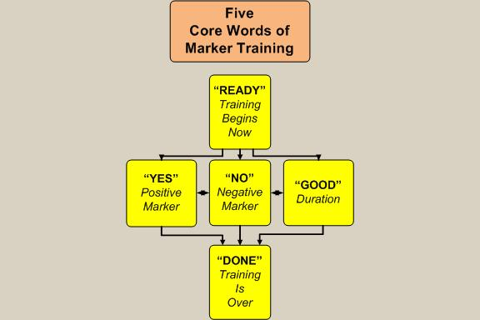
Leerberg.com

